Experiment 4

# Aim:

a) Design an XML document to store information about a student in an engineering college affiliated to VTU. The information must includeUSN, Name, Name of the College, Brach, Year of Joining, and e-mail id. Make up sample data for 3 students. Create a CSS style sheet and use it to display the document.

b) Create an XSLT style sheet for one student element of the above

# CSS:



Code 1: 4a.css

# XML:



Code 2: 4a.xml

# Output:

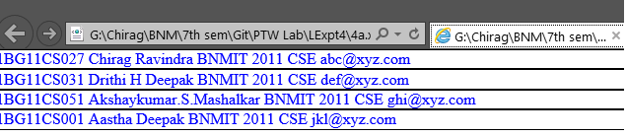

# XML:



Code 3 : 4b.xml

# XSL:



Code 4: 4b.xsl

# Output:

